**ER DIAGRAM:**

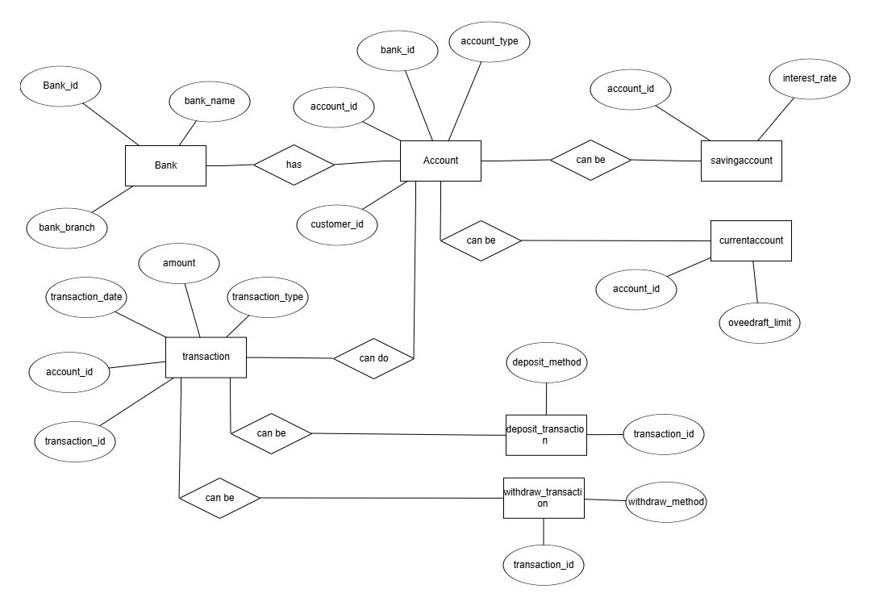

**Unified Modeling Language (UML) Diagrams:**

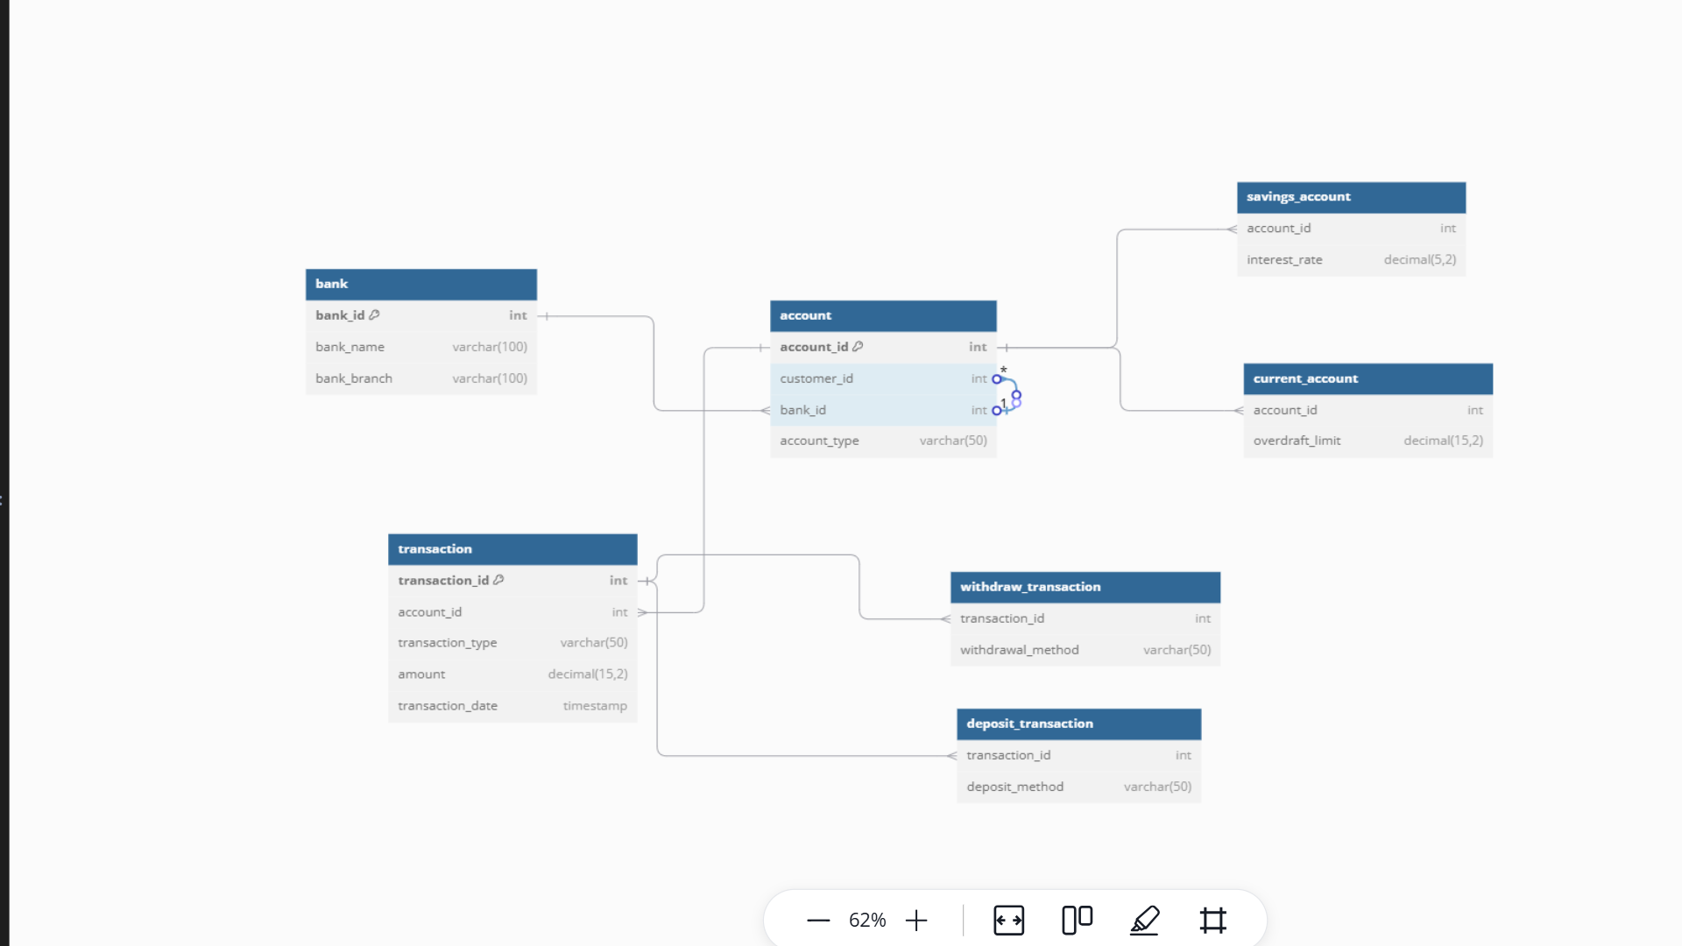

**Use Case Diagram:**

